How to use Mathematica via Tel Aviv university's server

If you are not familiar with Citrix software repository you probably have to download and install the client software that connects you to the server:

Download the exe file from here:

<http://www.tau.ac.il/cc/helpdesk/network-services/citric/citrix-windows/citrix-instalation/citrix-instalation.html>

If you had already installed this, you do not have to do this again.

After installation, go to <http://mytau.tau.ac.il/> log in with your username, ID and password.

After logging in, press on the "Citrix" hyper-link

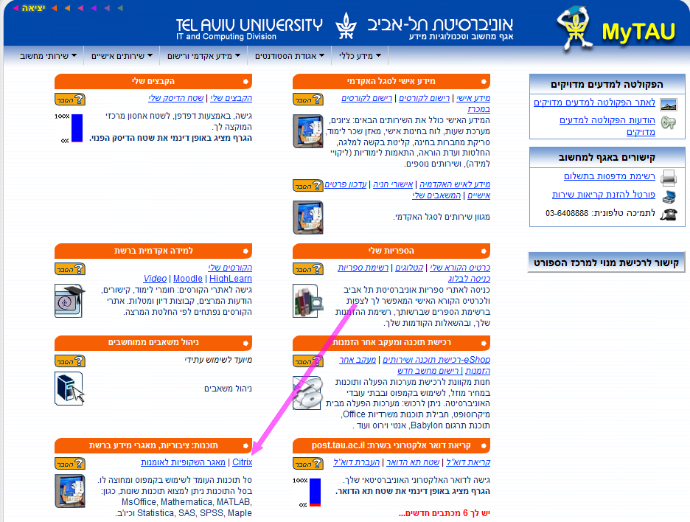

In the next screen choose "Mathematical" folder

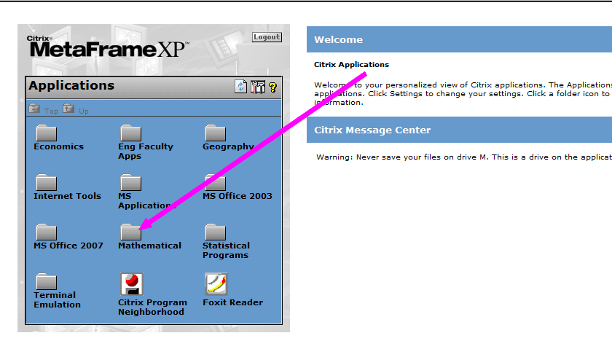

Press on the "Mathematica 7" icon.

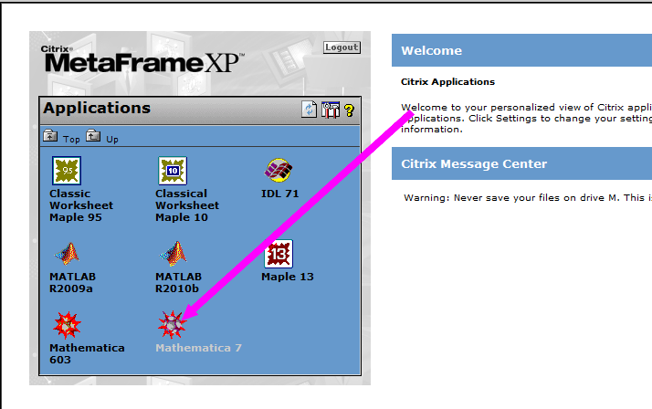

Wait a few seconds for establishing connection and:

